
HOSSAM MOHAMED IBRAHIM
Resume



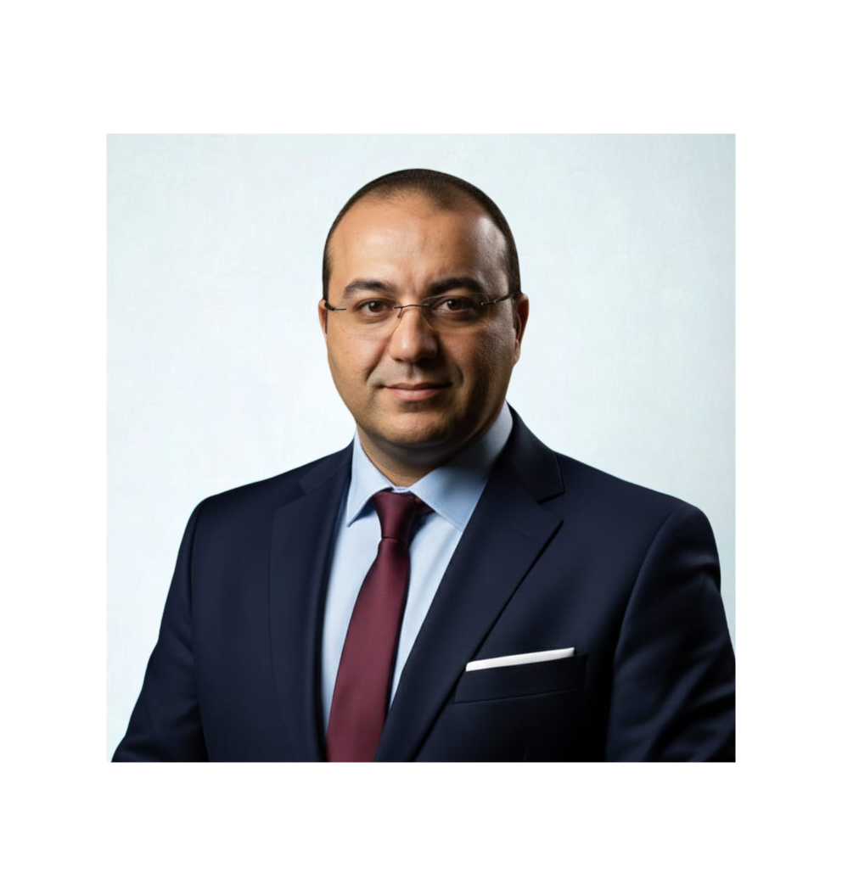 |  | Hossam Mohamed Ibrahim  Operations credit processing senior manager – central operations Sector " NXT Bank (formerly Arab Investment Bank Egypt — aiBank)”.  (Corporate Trainer & Soft Skills Coach)  Certified Trainer (TOT) and seasoned professional with over 20 years of leadership experience in the banking sector. Currently balancing a senior role in operations and risk management with a passion for training and coaching. Specializes in Professional Business Writing, Problem Solving, and Decision Making. Skilled at transforming complex challenges into practical, engaging training programs. Delivers effective soft skills and managerial sessions online and in-person for diverse audiences. Combines practical expertise with training excellence to develop talent and drive organizational growth.  Core Training Competencies  - Professional Business Writing  - Problem-Solving & Decision-Making Workshops  - Leadership & Team Coaching  - Training of Trainers (TOT) & Training packages Development  - Effective Communication & Presentation Skills  - Soft Skills & Managerial Training Delivery  Training & Education  - Emerging Leaders Program | Global Impact Consulting Group | 2023 - 2024  - Training of Trainers (TOT) Certification | Ain Shams University & Regional Training Center | 2023  - Preparing Training Packages (PTP) Certification | Ain Shams University & Regional Training Center | 2023  - Presentation Skills (The Show) | Logic Training & HR Development  - Stress Management: "Mind Your Body" | Quest Human Development & Change Agents  - Problem-Solving & Decision Making | Logic Training & HR Development  - Certified Manager in Risk Management (CMRM) | The Arab Academy for Banking & Financial Sciences  - B. Com. in Commerce | Cairo University | 2003  Training & Delivery Experience  - Designed and delivered multiple live online training courses for participants across various Arab countries, demonstrating strong virtual facilitation skills.  - Developed and recorded a specialized training course, which is currently hosted on prominent Egyptian e-learning platforms:  - Yanfaa Educational Platform  - Vision Educational Platform  - Created comprehensive, ready-to-use training packages for trainers, facilitating effective and standardized knowledge transfer.  - Leveraged 20+ years of leadership experience to provide real-world context in training on stress management, problem-solving, and professional communication.  Professional Experience  Arab Investment Bank Egypt(aiBank)  Operations Credit Processing Manager – Central Operations Sector | 2022 – Present  Corporate & SMEs Processing Manager – Central Operations Sector | 2018 – 2022  Credit Administration & Control Unit Section Head – Risk Sector | 2015 – 2018  National Bank of Abu Dhabi Egypt (FAB)  Credit Administration Senior Officer | 2011 – 2015  Cash Head | 2010 – 2011  Career Foundation (2000 – 2011): My early career encompassed building a strong foundation in external auditing and accounting before successfully transitioning into the banking sector. I progressed through core cash operations and credit administration roles at institutions like Piraeus Bank and NBAD, establishing a solid groundwork in operational risk and financial controls.  Training & Coaching Highlights  - Designed and delivered comprehensive online training courses for participants across various Arab countries.  - Developed ready-to-use training packages for trainers, facilitating standardized and effective knowledge transfer.  - Leveraged 20+ years of leadership experience to provide real-world context in training on topics like stress management, problem-solving, and effective communication.  - Mentored and coached numerous team members throughout my banking career, fostering professional growth and skill development.  - Utilized e-learning methodologies and adapted training approaches for cross-cultural audiences.  Skills  - Training & Facilitation: Curriculum Design, Virtual Training, Engaging Presentation  - Leadership & Coaching: Team Motivation, Performance Management, Talent Development  - Personal Effectiveness: Stress Management, Strategic Problem-Solving, Decision-Making, Planning & Organizing  I am excited to leverage my two decades of practical leadership experience and formal training certifications to empower individuals and contribute to the success of a forward-thinking training organization.  Sincerely,  Hossam Ibrahim

CONTACT
Phone - 01113434399

Email-coachhossameg@gmail.com

https://yanfaa.com/eg/instructors/HossamEbrahiem


Training of Trainers (TOT) Program Delivered in Sign Language
https://web.rooaya.com/courses



LinkedIn:
www.linkedin.com/in/hossam-ibrahim-32842196

Website –

https://icancoachyou.online/coaches/hossam-ibrahim


Personal Data
*Date of birth: 06/06/1982.
*Nationality: Egyptian.
*Marital Status: Married.
*Military Status: Exempted.

